# UNCOVER MY BELIEFS

What do you believe about your life?

What do you believe about yourself?

What are the lessons your parents taught you?

What do you believe about your dreams coming true?

What do you believe about your ability to create what you want?

Why do you have your current results in your life?

**WHAT DO I WANT TO BELIEVE?**

What are the results you most want in your life?

What are the beliefs that have kept you from getting these results so far?

What do you need to believe to get the results you want?

Why don’t you believe this yet? What thoughts get in the way?

# MENTAL REHEARSAL

Think about the changes you want to make and visualize yourself having already made them. What’s different about you?

How do you handle problems differently?

How do you feel differently?

How do you act differently?

How do you show up differently?

When you imagine yourself “practicing” for this part in your new life, what are you doing well, and what do you need to keep practicing?

How will you know when it has clicked for you?

List of new thoughts & emotions to practice. Record these and listen to them regularly. Examples:

* I am guided.
* Everything is as it should be.
* Everything happens for me.
* It was meant to happen the way it did.
* I am exactly as I should be.
* Everything happens right on time.
* The Universe is kind.
* I am not my mind—I am the Watcher of my mind.
* Love is always an option.
* Unconditional love is something I give to myself.
* I’m responsible for everything I think and feel.
* No one can cause an emotion inside me.
* People are allowed to behave the way they want—I am allowed to react the way I want.
* It’s not what I do—it’s who I am.
* There’s nothing I can do that wouldn’t be worthy of forgiveness.
* There’s nothing wrong with me.
* I am enough.
* Nothing has gone wrong here.
* I’m here to work on me.
* My purpose is the life I am living now.
* I am deeply loved.
* The world longs for what I have to offer.
* There’s nothing I truly want that I can’t have.
* Hard work feels amazing.
* I can do hard things.
* Familiarity is not the same as comfort.
* Comfort and safety are separate.
* Suffering is sometimes familiar, but not necessary.
* Worry serves no purpose.
* Money is easy.
* There’s plenty of time.
* Time is my friend.
* Everything I do is a choice.
* My past is perfect.
* There’s nothing they can do to make me happy—that’s my job.
* What I do doesn’t make me happy—what I think does.
* I don’t have fun—I am fun.
* What I look for, I will find.
* What others think of me is about them, not me (good and bad).
* Trying to get someone to love me, to feel love, is like trying to get someone to eat for me, to feel full.

GREAT QUESTIONS TO ASK EVERY DAY

* How can I be an example of what’s possible?
* How can I get the housework done and have fun at the same time?
* What can I do to laugh a lot today?
* How can I make today better than yesterday?
* How can I make my future more exciting than my past?
* How can I make myself a priority so I have more to give others?
* What do I love about myself?
* What am I grateful for?
* How can I honor my body today?
* What can I do to feel my emotions instead of eating or drinking them today?
* How can I become more connected to my internal joy?
* How can I make choices that benefit me and everyone around me at the same time?
* How can I live my best life?
* In what ways is my purpose the life I'm living right now?

# COACH YOURSELF

Pick one specific issue to focus on.

Describe the issue. Do a thought download.

Separate the facts from the thoughts.

Pick one thought.

Use TEBO.

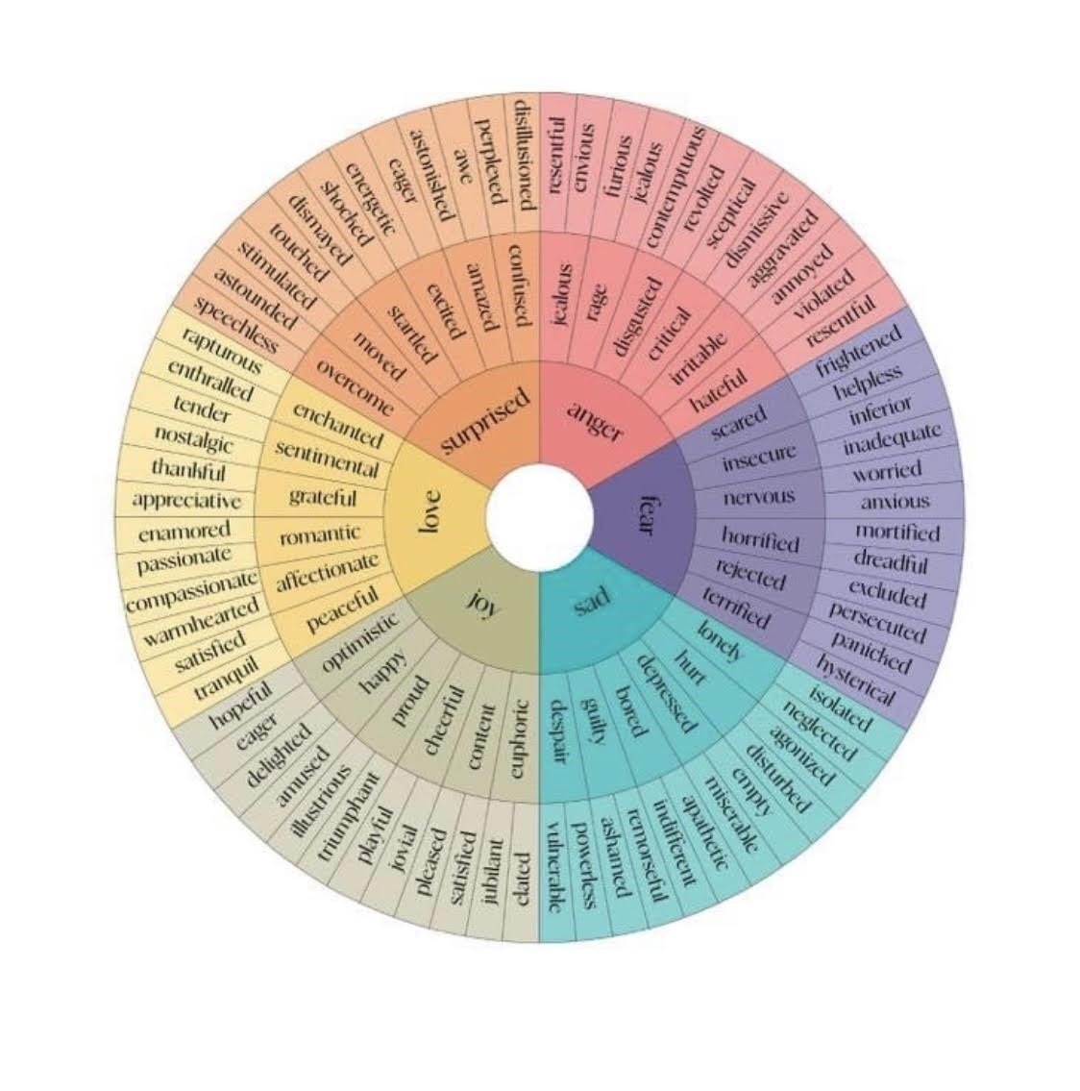

# EMOTIONS

1. What are you feeling now? Pick one from the Wheel.
2. Where is this feeling in your body? Is it moving now?
3. What color is this feeling?
4. Is this feeling hard or soft?
5. Is this feeling fast or slow?
6. How does this feeling make you want to react?
7. Why are you feeling this?

On a daily basis, what are your three most common feelings?

Why do you think you have these feelings on a daily basis?

What would you like your top three feelings to be?

Why?

How would your results change if you changed your top three feelings? Would you want to keep any of them? Why?

# INDULGENT EMOTIONS

How often do you feel overwhelmed, confused, worried, or anxious? Explain.

Pick the one you feel most often and give a specific example of when you feel it and why.

Do you believe you could go a day, a week, or a month without experiencing this feeling? Why or why not?

Can you see a reason why you might want to keep indulging in this emotion?

What might it cost you if you do?

# THE WORST THAT CAN HAPPEN (AN EMOTION)

What is the worst feeling you can imagine ever having to face?

What would that feel like in your body? Describe the location in your body and exactly how it would show up. Be careful to include all the details about the sensations and nothing about the thoughts that would be going through your head. Just notice how it would feel in each part of your body.

When you think about this feeling and the great lengths you have gone to avoid feeling this way, can you explain why that might be? A simple vibration is harmless in our body, so why do we do things to avoid it that might actually be harmful to us?

If you were willing to feel this emotion without fear, how might you act differently in your life? What might you do differently, and why?

# CONTRAST

## CONTRAST OF EMOTIONS Part One

What are the feelings you choose?

Imagine a silver platter of emotions. What are the ones you need? What are the ones you want to feel on purpose?

Sort them, if you want, into Positive and Negative.

## CONTRAST OF EMOTIONS Part Two

Pick an indulgent emotion: confusion, doubt, worry, overwhelm, victimized.

What thoughts might cause this feeling regularly for you:

What’s my plan for not indulging in this emotion: (This is a boundary. When I feel this, I will ______.)

## CONTRAST OF EMOTIONS Part Three

Circle or list the *three* most common feelings you avoid or resist below: discomfort, deprivation, urges, boredom, dissatisfaction, failure, insecurity, rage, anxiety

One of these emotions that I most often resist is:

Thoughts that cause this feeling:

My plan to allow this feeling on purpose: (This is a boundary. When I feel this, I will ______.)

## PROCESSING PAINFUL EMOTIONS

How can I use this pain?

How is feeling this right now perfect?

What can I do that comes from peace, is for me, and is not trying to change anything?

How can I accept this with grace?

# UPSETTING PAST EVENT

What happened? Do a free write.

Now, list only the facts of what happened.

What are you making these facts mean? (What is the story that makes this a problem?)

How do these thoughts feel?

Does this or did it make you want to numb out? Why or why not?

How do you want to feel?

What would you need to think/believe about this event to feel that way?

What have you learned from this event?

# UPCOMING EVENT

What is the event?

What will be challenging about the event?

What do you want to do at the event?

What is your decision ahead of time?

Your commitment?

What is your specific plan to carry this out?

When you get to the event, how will you justify or excuse not following this plan? (Anticipate the obstacles.)

Visualize three scenarios in which you are challenged and you take the action you want to take.

If it gets really hard, what is your plan?

Write a message to yourself here that you could read at this event to remind you of your plan.

Write a mantra to yourself that you can say quietly in your head.

## TAKING RESPONSIBILITY FOR YOUR FEELINGS

Name a person or circumstance that you believe is causing the negative feeling.

Describe how the thoughts are making you feel.

Describe why you think the thoughts have the power to control your feelings in this way.

What is the thought you’re thinking that’s really causing this feeling?

Can you see that it’s the thought and not the person or circumstance causing the feeling?

How might you take responsibility for your feelings in the future?

# THE MANUAL

Think about someone you want to change and write their name here.

Write, in detail, what you would like them to do.

For each item, write down why you want them to behave in this way.

How do you think you would feel if they behaved this way?

How would your thoughts about them change if they behaved this way?

Do you want them to behave this way even if they don’t want to? Why or why not?

What do you make it mean when they don’t behave this way?

When someone wants you to behave in a certain way to make them feel good, what is that like for you?

# BOUNDARIES

Definition: “If you do ______, I will do _______.”

What is the boundary violation?

What is the boundary you want to set?

The request: If you...

The consequence: Then I will, …

What are your fears (if any) around establishing this boundary?

What are the benefits of establishing this boundary?

How will you set this boundary? (You don’t need to tell anyone.)

How will you ensure that you honor your boundary?

UNCONDITIONAL LOVE

Think of someone who’s challenging for you to love.

Write the reasons why you find this person hard to love.

What are your thoughts about this person that prevent you from loving them more?

What conditions have you put on loving this person? List them.

What does it feel like when you’ve chosen not to love this person?

What would it be like to love this person without conditions?

List a specific example in which this person does something you don’t like. What would it take and be like to love them in this moment?

How is unconditional love different from love? How does it serve you?

Is there ever a time when love is not a good choice? Why or why not?

Make a list of all the things you like and appreciate about yourself. They can be small things or big things—please write down at least 12 things.

I’VE BEEN MEANING TO TELL YOU

Write an “I’ve been meaning to tell you” Letter below. This is a letter you can send or not send.

Dear _____________ I’ve been meaning to tell you:

I admire you for:

I’m thankful for:

I remember when:

You have shown me how:

You told me:

I’m grateful for:

I love you because:

Person of Focus: ____________

Judge this person. Don’t hold back. Let all the “ugly” judgments out of your head. Don’t edit yourself or try to be appropriate or kind. Get it all out.

Now, go back through and notice how many of these judgments also apply to you. Circle those that are true about you. Notice that most judgments of others are projections we have of ourselves.

Describe the Manual you have for the person of focus. What are your expectations of that person? What do you most want that person to do, and why? Let yourself go to a perfect world where that person does exactly what you want them to do and when you want it. Be specific, and allow yourself to be outrageous.

What would you be thinking and feeling if that person did all these things perfectly? Notice that you can think and feel these things anyway.

Allow that person to be who they are meant to be. So, who is that person? What do they do? How do they act? What are they consistent about? If you aren’t trying to control them or interfere, who are they in their actions?

Why do you imagine that person does these things and is this way? What thoughts do you imagine drive that person’s actions?

Do you love this person unconditionally? Why or why not? Make a note of when you do love them and when you try to withhold love from this person. Remember, their lovability is 100%, so what’s your excuse when you don’t love them?

How do you show up in this relationship? Do you show up knowing that your lovability is 100%? Do you try to get them to love you more for your sake? How? Does it work? Why or why not?

Who do you want to be in this relationship? In other words, what kind of employee, spouse, sibling, or friend, do you want to be? Make sure you think about this separately from the other person’s behavior— don’t let that determine who you are. Decide who you want to be. Take some time to write it all out.

How do you want to feel? Why?

How do you want to act and show up?

What do you want to offer to this person?

How do you want to think? Remember that your relationship with someone is all about your thoughts about them and yourself within that relationship.

How do you want to think about yourself in this relationship?

How do you want to think about the other person in this relationship?

How do you want to define and think about your relationship together?